**Project Documentation**

**FitFlex-Your Personal Fitness Companion**

**1.Introduction**

# ✓ Project Title: FitFlex-Your Personal Fitness Companion

**Team ID:**

**NM2025TMID31670**

❖ **Team Leader:**

➢ NAME: ANITHALAKSHMI S

MAIL ID: ssanithalakshmi@gmail.com

❖ **Team Members**

* NAME:ABARNA A

MAIL ID: anandarapuli@gmail.com

* NAME: KAVIYA R

MAIL ID: kaviyaraja6379@gmail.com

* NAME: SHOBITHA K

MAIL ID: karthicksundharam77@gmail.com

# 2. Project Overview

**Purpose:** FitFlex -Your Personal Fitness companion refers to various distinct products and services, including the FITFLEX Tummy Trimmer for abdominal exercise, the Fit Flex fitness app offering personalized workout and nutrition plans, the Fit & Flex brand of healthy snacks, and the Fit Flex gym, which provides a physical space for workouts. **Features:**

* Fitness companion
* Secure chat system
* Feedback and review system
* Admin control panel

**3. Architecture**

❖ Frontend: React.js with Bootstrap and Material UI

# 4. Setup Instructions

❖ **Prerequisites:**

* Node.js
* Git
* React.js
* Express.js – Visual Studio Code  **Installation Steps:**

# Clone the repository git clone # Install client dependencies cd client npm install

# Install server dependencies cd

../server npm install

# 5. Folder Structure

SB-Works/

|-- client/ # React frontend

|__components/

L__ pages/

# |__ server/ # Node.js 6. Running the Application

❖ **Frontend:**

* cd client
* npm start

❖ **Access: Visit** [**http://localhost:3000**](http://localhost:3000/)

# 7. API Documentation

❖ **User:**

* /api/user/register • /api/user/login  **Projects:**
* /api/projects/create
* /api/projects/:id • Applications: /api/apply

❖ **Chats:**

* /api/chat/send
* /api/chat/:userId

# 8. Authentication

* **JWT-based authentication for secure login**
* **Middleware protects private routes**

# 9. User Interface

* Landing Page
* Freelancer Dashboard
* Admin Panel
* Project Details Page

# 10. Testing

* Manual testing during milestones
* Tools: Postman, Chrome Dev Tools

# 11. Screenshots

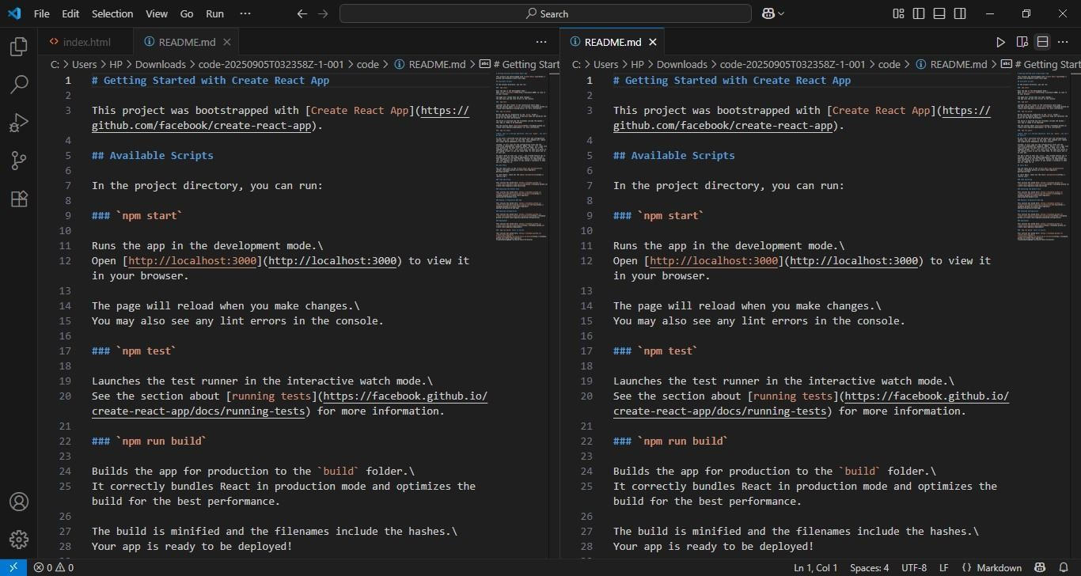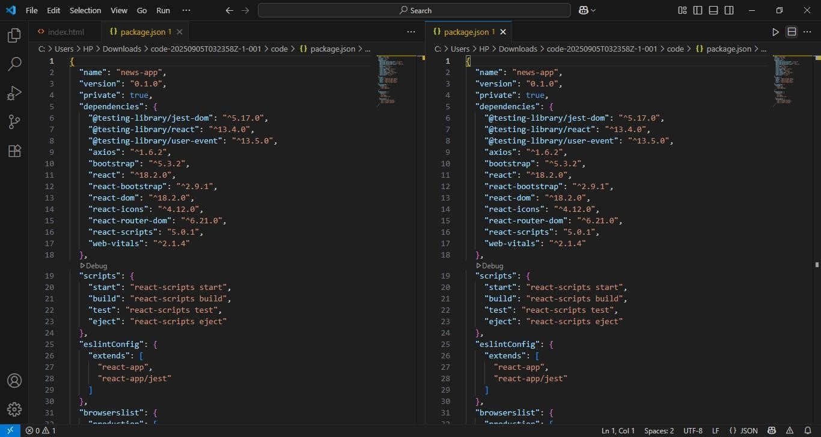

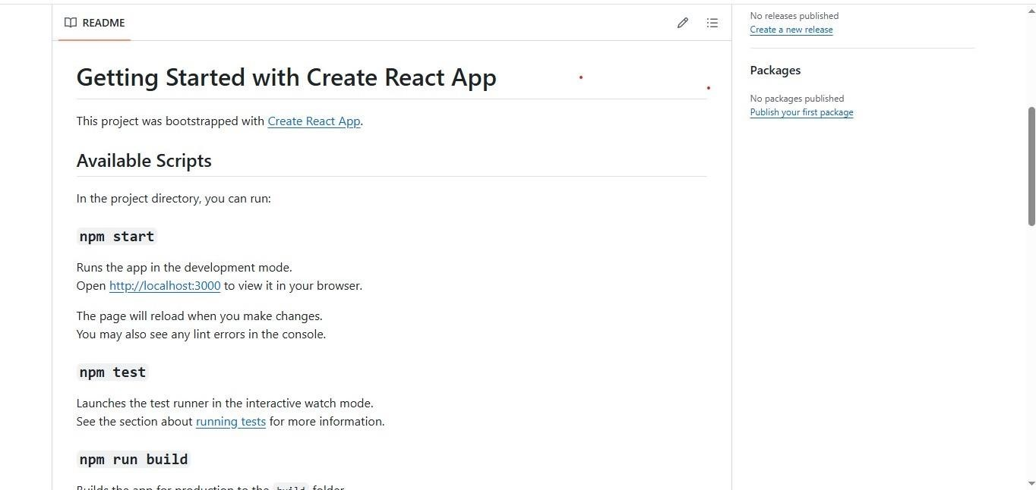

1. Known **Issues**
   * API Rate Limits
   * Server Problem
   * Navigation Glitches
2. Future Enhancements
   * Analytics Dashboard
   * Search Functionality
   * User Authentication